WORSHIP FOR SUNDAY, July 17, 2022

CHIMES

WELCOME AND ANNOUNCEMENTS –Emma
- Welcome to our third Taize style prayer service with reflections from the Psalms. Please feel free to light a candle here in the front as a prayer.
- Today we will not be passing the plates for offering, please give at the plates at the door as you leave.
- During the month of July we are collecting school supplies for Shelby Elementary School. Support this important work by bringing in supplies for students.

One: No matter who you are, or where you are on life’s journey,
All: You are welcome here!

CENTERING PRAYER –Tyler

Bless the Lord
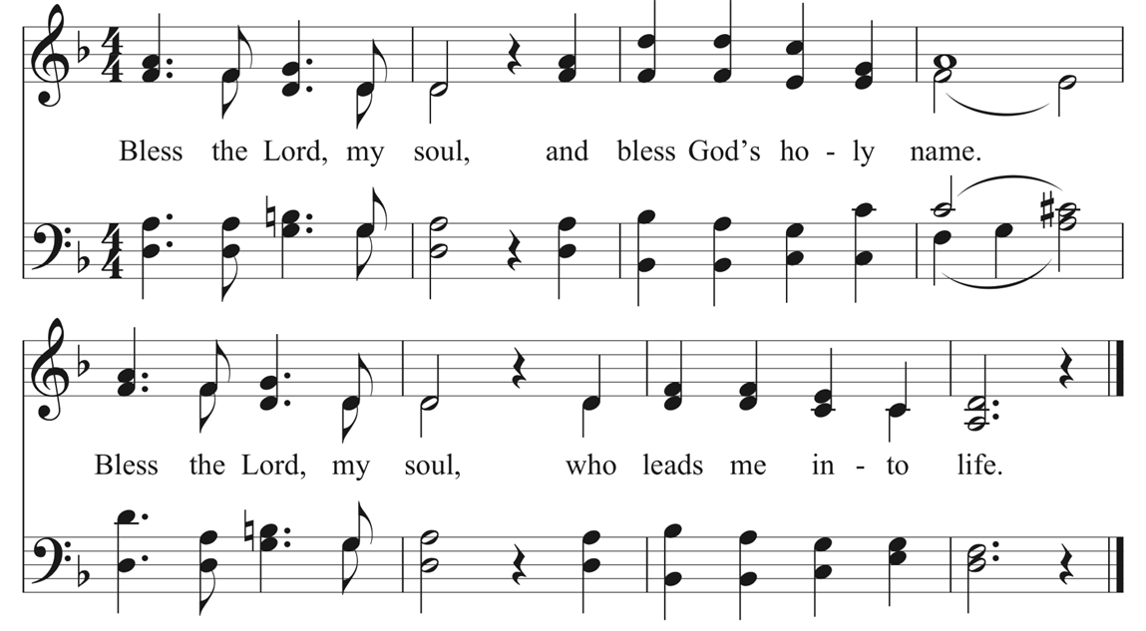

Wait for the Lord
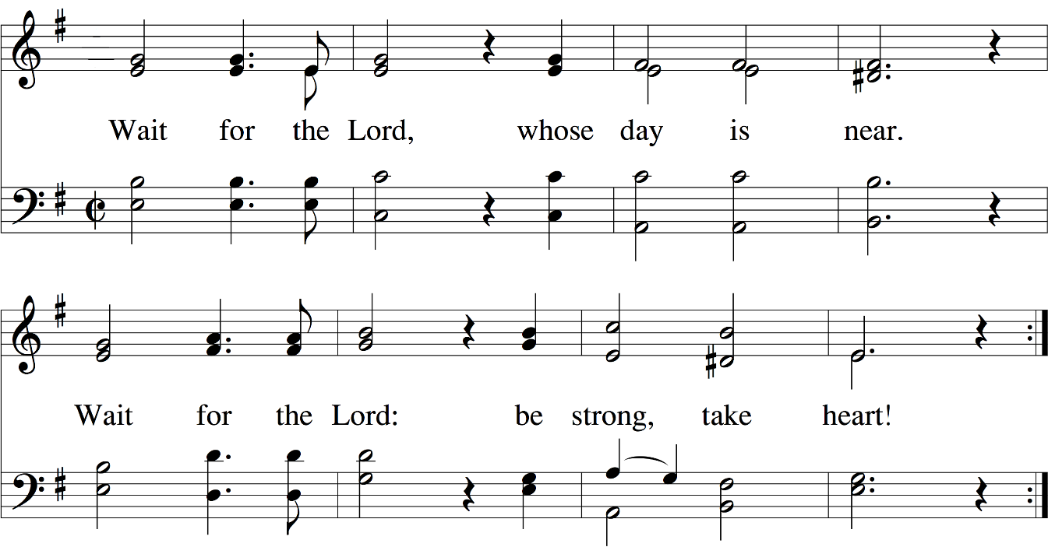
SCRIPTURE READING Psalm 74:1-11 – Emma

O God, why do you cast us off forever?
Why does your anger smoke against the sheep of your pasture?
Remember your congregation, which you acquired long ago,
which you redeemed to be the tribe of your heritage.
Remember Mount Zion, where you came to dwell.
Direct your steps to the perpetual ruins;
the enemy has destroyed everything in the sanctuary.

Your foes have roared within your holy place;
they set up their emblems there.
At the upper entrance they hacked
the wooden trellis with axes.
And then, with hatchets and hammers,
they smashed all its carved work.
They set your sanctuary on fire;
they desecrated the dwelling place of your name,
bringing it to the ground.
They said to themselves, “We will utterly subdue them”;
they burned all the meeting places of God in the land.
We do not see our emblems;
there is no longer any prophet,
and there is no one among us who knows how long.
How long, O God, is the foe to scoff?
Is the enemy to revile your name forever?
Why do you hold back your hand;
why do you keep your hand in your bosom?

Our Darkness
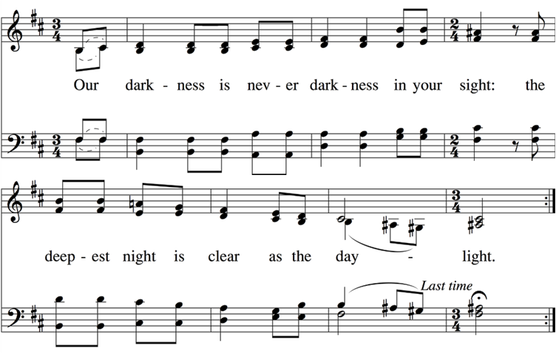

SCRIPTURE READING Psalm 74:12-17, 20-21 –Tyler

Yet God my King is from of old,
working salvation in the earth.
You divided the sea by your might;
you broke the heads of the dragons in the waters.
You crushed the heads of Leviathan;
you gave him as food for the creatures of the wilderness.
You cut openings for springs and torrents;
you dried up ever-flowing streams.
Yours is the day, yours also the night;
you established the luminaries and the sun.
You have fixed all the bounds of the earth;
you made summer and winter.

Have regard for your covenant,
for the dark places of the land are full of the haunts of violence.
Do not let the downtrodden be put to shame;
let the poor and needy praise your name.

Your Word, O Lord
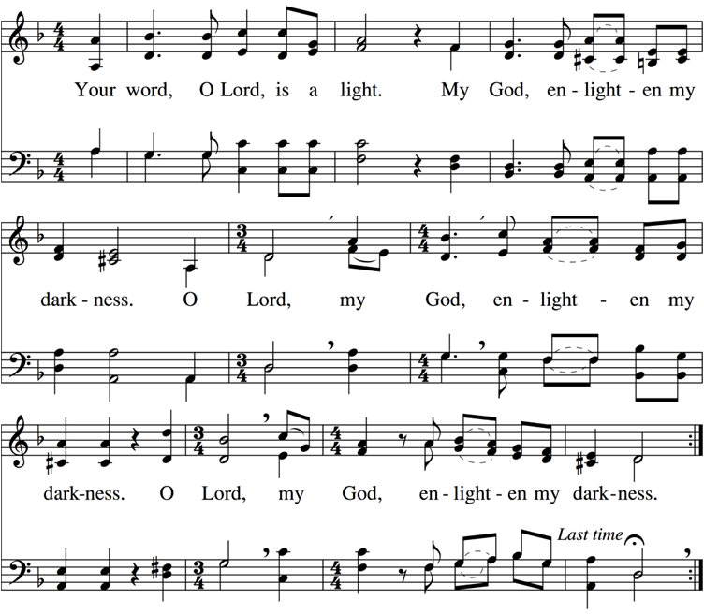

MEDITATION Rev. Emma Loane
The theme
We’ve been spending some time in the Psalms this month. These are the collection of songs, poems, prayers, many of which were likely used in rituals and worship in ancient places of gathering. We’ve discovered that the Psalms don’t shy away from the complex and often paradoxical experiences of human life. Maybe that’s why they are quoted by Jesus more than any other book in the Hebrew Bible.
They witness to the coexistence of faith and doubt, trust alongside questions – like Tyler talked about a few weeks ago. They hold praise and sorrow, joy and pain, strength and weakness together. Reminding us that even amidst our brokenness, a spontaneous shout of “Hallelujah!” may break out. They bear raw and honest witness to the reality of the human experience, the good and the bad, the stuff we’re proud of and the stuff we’re ashamed of. Emotions and situations that are often messy and difficult to explain.
So, I hope that in these 3 weeks you have been able to spend some time reading, meditating on the Psalms. Finding yourself in this ancient songbook and sensing not only a connection with those that have gone before, but a connection with the Divine who intimately knows and cares for you.
A story
I received a text from my cousin who was volunteering at a church camp in Scotland this past week. She belongs to a Reformed Presbyterian tradition whose practice is to sing Psalms without instrumentation. And she sent me 5 or 6 recordings of Psalms sung at camp, teenagers singing, all acapella in 4-part harmony. The voices weren’t trained or polished, but it brought me right back to the services I used to attend in the little country meeting houses.
And it reminded me, as well, of the few months I lived with my grandmother before she passed. How I would go to bed, with the baby monitor on my nightstand. I would be on high alert every time I’d hear a rustle of the sheets across the ripple mattress, or labored breathing. There’d be times I’d hear her talking in her sleep, words that often didn’t make much sense to me. And I’d run downstairs to sit by her bedside and without fail, in moments of lucidity, she’d ask for the Psalms. Familiar phrases in poetic language, memorized, putting words to unspoken prayers.
The Lord is my shepherd;
I shall not want.
He makes me lie down in green pastures; (Ps 23)

I will lift up my eyes to the hills—
From whence comes my help?
My help comes from the Lord,
Who made heaven and earth. (Ps 121)

How lovely is Your dwelling,
O Lord of hosts!
My soul longs, yes, even faints
For the courts of the Lord; (Ps 84)

Be still, and know that I am God; (Ps 46)

Words that remained in her hear, long after her day-to-day memory faded. And I’ll never forget reading Psalm 139 at her funeral service.
O Lord, You have searched me and known me.
You know my sitting down and my rising up;
You understand my thoughts from afar
You comprehend my path and my lying down,
And are acquainted with all my ways.

The text
Our passage today, may not be one of the most well know of the Psalms. Psalm 74 is a psalm of exile, a song of lament over the destruction of the temple in Jerusalem. Lament is something we don’t talk about or practice a whole these days, but in the book of Psalms, 60 of the 150 are categorized as lament – that’s 40%.
There are individual laments were the individual worshipper cries out to Yahweh in time of need. And then there are communal laments, like our passage today, which expressed the feeling of loss and sorrow of an entire people.
These lament psalms are important for several reasons. First, they give us words for the deepest, darkest nights of our lives —when the bottom drops out, when the pain seems too much to bear. When we feel completely alone, and set adrift. Second, they tell us that God is big enough for everything we’ve got —our pain, our anger, our questions, our doubts. They even suggest that faith is entirely comfortable with challenging God. And that God’s Divine presence is with us precisely when it feels like it isn’t there.
Brueggemann calls these psalms of lament “psalms of disorientation” — because they admit that life is not as well-ordered as a simple Sunday School faith may pretend. They acknowledge that life is really messy, and they protest to heaven that things should not be as they are. And they ask WHY?

O God, why do you cast us off forever?
Why does your anger smoke against the sheep of your pasture? (v1)
Why do you hold back your hand;
why do you keep your hand in your bosom? (v11)

And these psalms, through prayer, evoke action from God — often for God to step in a annihilate enemies, or remain faithful to promises made in the past. In our psalm, it’s a call of God to remember:

Remember your congregation, which you acquired long ago…
Remember Mount Zion, where you came to dwell. (v2)

And, often these psalms of lament help move the sufferer to a new place. When we can find sold ground again even during the aftermath of disorder and loss. The speak to a hope of fresh understanding, divine insight– of ourselves, of our world, and all in light of who God is and what God has done.
These Psalms of Lament remind us that through the thick and thin, the Holy Mystery that is God, remains with us. Not always with answers, or explanations, but in compassionate solidarity with our real-life human experiences.
Conclusion
And these human experiences are timeless and continue to be expressed in contemporary worship music. One of my favorite contemporary songs is called Weep with Me, by a Northern Irish group call “The Rend Collective.” And I’ll finish will these words:
Weep with me, Lord will You weep with me?
I don't need answers, all I need is to know that You care for me
Hear my plea
Are You even listening?
Lord I will wrestle with Your heart
But I won't let You go
You know I believe
Help my unbelief

Yet I will praise You
Yet I will sing of Your name
Here in the shadows
Here I will offer my praise
What's true in the light
Is still true in the dark
You're good and You're kind
And You care for this heart
Lord I believe, You weep with me

Dear friends, may the Psalms whether those of praise, doubt or even lament remind you of that, “What's true in the light, is still true in the dark.” That even, maybe even especially, in moment of deep sorrow and distress, God is there, God is faithful, and God will lead you through. Amen

ANTHEM Celtic Prayer Cabaniss/Purifoy
Hear my voice, most gracious Lord. O hear the prayer within my soul.
May the words rise to You with songs of praise. Give me peace, touch my heart to feel Your everlasting love. Hear my prayer, Holy Lord in the morning when I rise.
Lead my life, most faithful Lord, to seek Your thoughts and know Your will.
For my soul longs to dwell within Your care. Give me strength, guide my steps to live according to Your Word. Lead my life, Holy Lord in the beauty of Your grace.
Search me, O Lord and know my heart. Try me, O God and know my thoughts.
Find any wrong that dwells within my heart and lead me forever in Your everlasting love. I will sing with all my heart. I sing of God's unchanging love.
For His mercy endures forevermore. May my trust rest in God to know the fullness of His grace. Hear my prayer, Holy Lord, in the stillness of this hour.

A TIME OF SILENCE
In God Alone My Soul
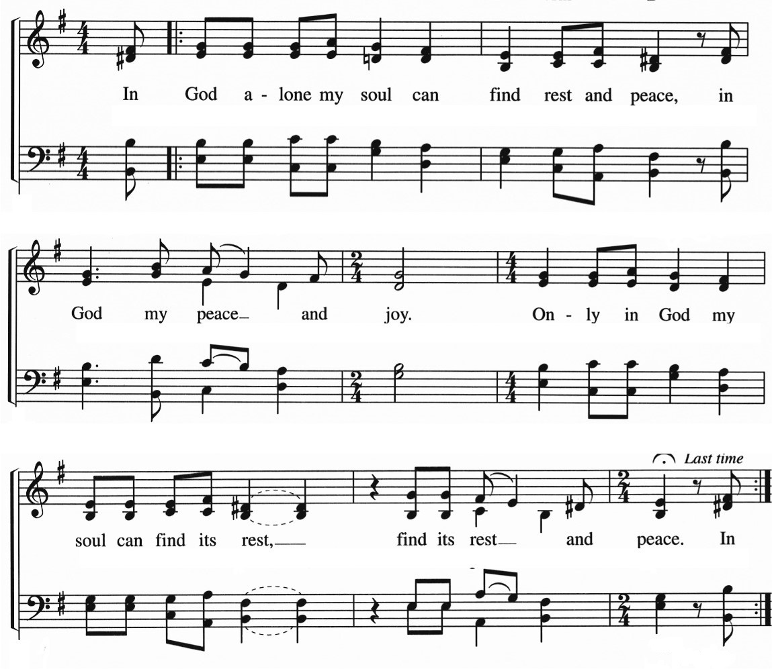
INTERCESSION – Tyler
Source of all Life, creator of the earth and all that is in it, we lift our prayers of thanks to you. For the beauty of the earth that surrounds us, thanks be to you, creator of the heavens and the earth, to whom all things belong. Eternal One,
All: We lift our prayers in faith.
Source of all being, our life span is short, at any moment to be taken from us. Free us from greed, and fill us with generosity. Strip us of our fear and strengthen us to love one another as you have loved us. Eternal One,
All: We lift our prayers in faith.
For those who struggle to find adequate food and clean water, clothing and shelter and the other basic needs of life, we pray that governments and agencies, including the church, will reach out to change the course of their history for good, sharing from the abundance held by others. Grant us the courage and generosity to be part of the solution. Eternal One,
All: We lift our prayers in faith.
We pray for places torn apart by violence and for places which look to violence as a solution. We pray for communities feeling threatened by their neighbors. Amplify the calm voices calling for peace and reconciliation that they might be heard, that hardened hearts might be softened, that ancient divisions might be mended. Eternal One,
All: We lift our prayers in faith.
We pray for travelers. We pray for refugees looking for safety and welcome, and for students who have left the familiar to study in distant places. Eternal One,
All: We lift our prayers in faith.
For those who have known illness and pain, suffering and worry, we pray for an over-shadowing of your mercy upon them. For …Encircle them and their families with your comforting embrace. Eternal One,
All: We lift our prayers in faith.
We pray for those who have been visited by loss and grief. For…and all who mourn. Illuminate their darkness. Comfort and strengthen them. Eternal One,
All: We lift our prayers in faith.
In this moment of silence, hear the joys and concerns in our hearts.
SILENCE
Eternal One,
All: We lift our prayers in faith.
Giver of hope, we lift our prayers in faith looking always toward the source of peace and goodness:

LORD’S PRAYER
Our Father in heaven, hallowed be your name.
Your Kingdom come, your will be done, on earth as in heaven.
Give us today our daily bread.
Forgive us our sins, as we forgive those who sin against us.
Lead us not into temptation, but deliver us from evil.
For the kingdom, the power and the glory are yours. Now and forever. Amen

SACRAMENT OF HOLY COMMUNION – Tyler
Eat This Bread
During the singing of this song, you may go forward and partake of the communion elements, which are individually wrapped for safety.
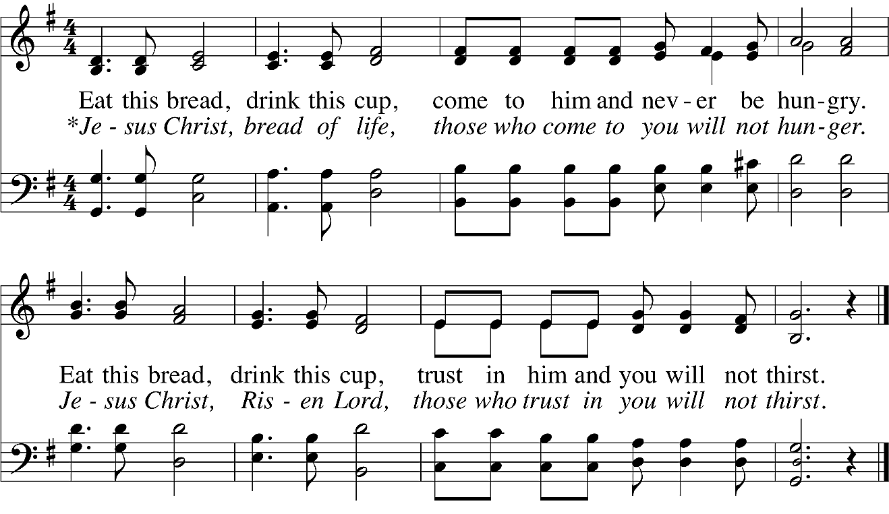

CLOSING PRAYER (in unison) –Emma
God of Lament and Hope,
bless us with your grace as we leave this place.
As siblings of one another and of the Divine,
we acknowledge our vulnerability, even as we look to you.
We are confident that your presence
will give us the courage to move forward with hope.
We ask this in your name, knowing that we are held always
in the unity of your Creative Spirit
who is with us now and forever. Amen.

Let Your Servant Now Go in Peace

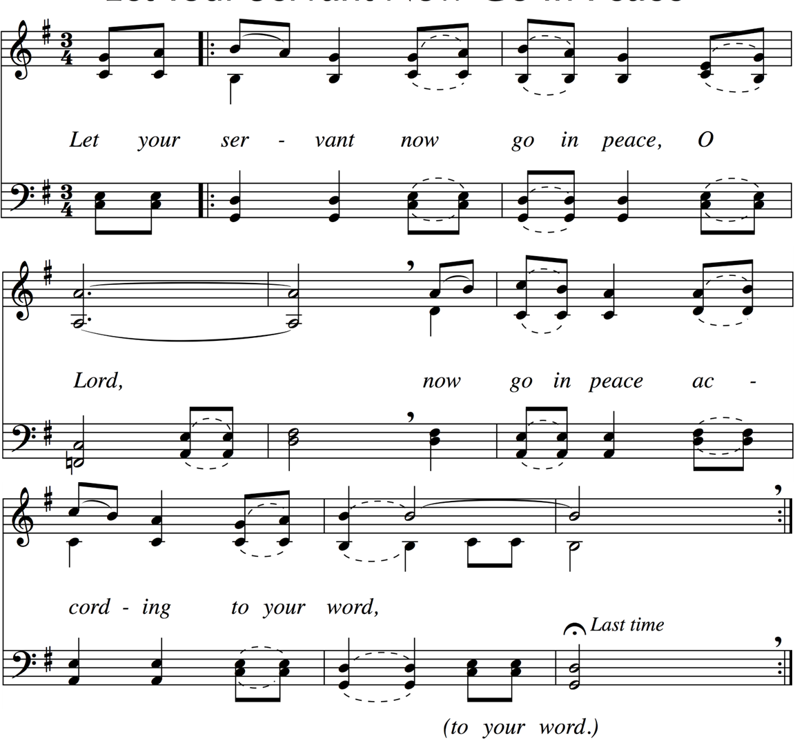

You are invited to sit quietly for a moment and to leave quietly.

Thank you to all our instrumentalists this week:
Terry Burden, guitar; Melinda Ebbs, clarinet;
Steven Kinnamon, violin; Darian Wicker, viola

SAINT ANDREW UCC STAFF
Rev. Lori Miller-Price, Senior Pastor pastorlori.saintandrewucc@gmail.com
Rev. Emma Loane, Associate Pastor pastoremma.saintandrewucc@gmail.com
JR Cannaday, Minister of Music jrcannaday.saintandrewucc@gmail.com
Dr. Tyler Mayfield, Sabbatical Supply tyler.saintandrewucc@gmail.com

WHERE TO FIND OR CONTACT SAINT ANDREW UCC
Website www.saintandrewucc.org
YouTube Channel StAndrewUCCLouisville,KY
Facebook facebook.com/saintandrewucc
Phone Number 502.452.1777
ANNOUNCEMENTS
ST. ANDREW’S JULY BENEVOLENCE
Shelby Elementary School. We will be collecting school supplies for them in July.
Supply list for a First Grader
1 back pack - no wheels
3 glue sticks
24 pencils
1 box of 24 crayons
1 box of 8 washable markers
5 notebooks
1 pencil box or pencil pouch
5 two-pocket folders
1 pair of scissors

Dicey Ladies & Men (Bunco) Wednesday, July 27th 11:30am.
Bring a sandwich and friend.

“Welcome Home Open House”
on Sunday, August 7th 4:30-7:30pm.
Join us at church for wine, cheese, and charcuterie to welcome Pastor Lori back from her sabbatical.

Communications Ministry
We are looking for a few folks who are interested in assisting/planning/doing communications for St. Andrew. Is that you? We hope so!
Communications are a vital part of both our internal communications as a church family and our external/outreach communications to the wider community. They include audio/visual, print, flyers, Heartbeat, Sunday bulletin, flyers, social media, signage, email, radio/TV and the list goes on!
We need people with ideas and also those who may want to do some of the creating. If you are interested and want to help or just learn more, we will have an initial meeting immediately after church on July 24. We will meet in the conference room behind the Gathering area.
If you have questions or can’t attend that day but are interested, please see Lynn Carrie or call/text her at 502-693-0535. Thanks and hope to see some of you at the meeting!

